Aaiza Irfan

SP20-BCS-001

**THEORY OF AUTOMATA**

**ASSIGNMENT #2**

**Question 1:**

**Design PDAs for the following language:**

**Part i:**



**Part ii:**

**All lengths of palindrome language**

For even length palindrome we have the language {wwr | w ∈ (a,b)}  
For odd length palindrome we have the language {wcwr | w ∈ (a,b)}  
For all lengths of palindrome to be accepted, it needs to accept both odd and even length.

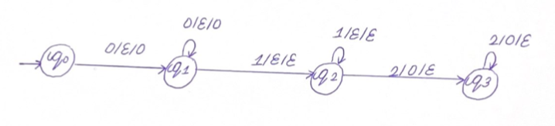

**Part iii:**



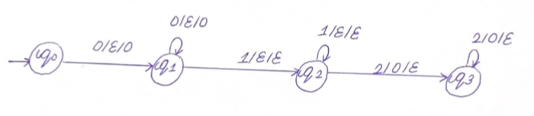

**Question 2:**

**Prove that the following languages are irregular using the pumping lemma**

The pumping lemma has three conditions that must be satisfied for the language to be regular:

L is a regular language. Then there exists a pumping constant ‘p’ such that for every string w in L 🡪 |w| ≥ p

We can break w into three strings, w = xyz, where

* y cannot be null
* |xy| ≤ p
* For all k ≥ 0, the string xykz is also in L.

Using these conditions, we will prove the following languages are irregular

**Part i:**



Diving the given language into xyz

x=an  y=bn z=bn

Let k=2, and then xy2z should be also in the language

This gives us

anb2nbn = anb3n

Examples of this are:- abbb, aabbbbbb

This does not satisfy the language and is irregular

**Part ii:**

**Odd palindrome (odd-length string)**

Odd-length palindromes are {wcwr | w ∈ (a,b)}

For this language, we can assign it to xyz

x=w y=c wr

Let k=2, and then xy2z should be also in the language

This would give us

wc2wr which would give us even length

as this will be: aabbccbbaa

Hence, the language will not be irregular

**Question 3:**

**Design a Turing machine to recognize the following languages:**

**Part i:**



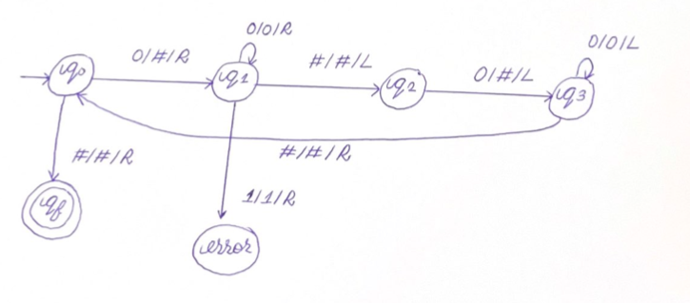

**Part ii:**



